**WEEK 6**

**Class 10**

Go over midterm

Business Plan- Part 1 due in a week

* Go over and time to work
* Financials
* Industry Analysis
* Market Analysis

Marketing

Technology

Operations and Costs

**Videos**

<https://www.youtube.com/watch?v=pW8MCKqpa_E>

<https://www.youtube.com/watch?v=YX4PFEBX8Co>

**Software**

<https://www.xero.com/us/>

[QuickBooks](https://search2.quickbooks.com/t/qbks-14692/b/get-quickbooks/?cid=ppc_g_Exact_QB_US_B_QuickBooks-Top-Term_Exact_Tier1_G_S_quickbooks_txt&cvosrc=ppc.google.quickbooks&matchtype=e&adposition=1t1&creative=106564566608&content=&cvo_search=1&mobile=&X1ID=~uk~&g)

**Class 11**

OLD

**Updates**

Midterm Reminder

Grades

Career Fair

**Topic**

Break Even Analysis

Financing your Company

Starting a Business

**Review**

Break Even Analysis

Supply and Demand

**Assignments**

Excel- Create a Payment Cost Sheet

* Online
* In Person
* Merchant (Store)
* Cash, Venmo Checks

ICA Excel Assignment

**Class 8**

Slower overview of websites

Group Time

**Class 9**

Balance Sheet

Statement of Cash Flows

Taxes

Depreciation

**Mark Cuban**

https://www.youtube.com/watch?v=KYneLGRTgy8&t=220s

**WEEK 3**

**Class 5**

Online Bonsai

* Company Type
  + http://sos.oregon.gov/business/Pages/starting-business.aspx
* Supply Chain
* Online Vendor
* Grow to Nursery
* Book keeping starters

Groups Overview

* Idea Solidification

Excel Assignment

Economic Systems

Industry Analysis

Bonsai Company Business Type

* Industry
* Market

Dropbox

Go Over my Analysis

**Technology**

Domains

Hosting

Simple Page

Frameworks

**Youtube**

Paul

https://www.youtube.com/watch?v=2lcp0uZsY7k

Peter

https://www.youtube.com/watch?v=UUzvo4HwojU

**Class 6**

Solidify Idea

Start List of Variable and Fixed Costs in Excel

**Notes**

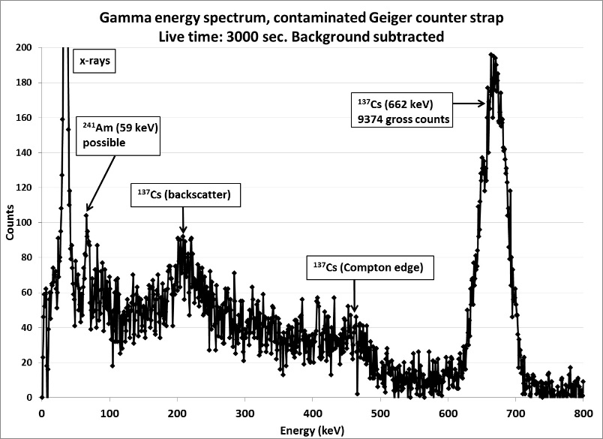

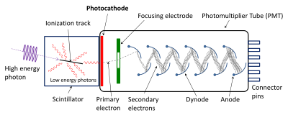

### Gamma

The quantum efficiency of a [gamma-ray](https://en.wikipedia.org/wiki/Gamma_ray) detector (per unit volume) depends upon the [density](https://en.wikipedia.org/wiki/Electron_density) of [electrons](https://en.wikipedia.org/wiki/Electron) in the detector, and certain scintillating materials, such as [sodium iodide](https://en.wikipedia.org/wiki/Sodium_iodide) and [bismuth germanate](https://en.wikipedia.org/wiki/Bismuth_germanate), achieve high electron densities as a result of the high [atomic numbers](https://en.wikipedia.org/wiki/Atomic_number) of some of the elements of which they are composed. However, [detectors based on semiconductors](https://en.wikipedia.org/wiki/Semiconductor_detector), notably hyperpure [germanium](https://en.wikipedia.org/wiki/Germanium), have better intrinsic energy resolution than scintillators, and are preferred where feasible for gamma-ray [spectrometry](https://en.wikipedia.org/wiki/Spectroscopy).

### Neutron

In the case of [neutron](https://en.wikipedia.org/wiki/Neutron) detectors, high efficiency is gained through the use of scintillating materials rich in [hydrogen](https://en.wikipedia.org/wiki/Hydrogen) that [scatter](https://en.wikipedia.org/wiki/Scattering_theory) neutrons efficiently. [Liquid scintillation counters](https://en.wikipedia.org/wiki/Liquid_scintillation_counting) are an efficient and practical means of quantifying [beta radiation](https://en.wikipedia.org/wiki/Beta_particle).

**Neutrons**

HEU- few neutrons

It is important for organizations considering purchase and deployment of neutron-detecting PRDs and SPRDs to understand the limitations of neutron detection using these devices. As discussed in Section 2.3.2, neutron detection is useful to detect plutonium, but not highly enriched uranium (HEU), because HEU emits very few neutrons.

The neutron detectors in PRDs and SPRDs are necessarily small and therefore not highly sensitive. An operator wearing a typical neutron detecting PRD while performing normal duties such as a foot patrol might not discover nearby plutonium using neutron detection alone. If hidden plutonium is not surrounded by shielding that absorbs gamma rays, the gamma alarm of a detector will generally be triggered at a larger distance than the neutron alarm. While neutron detection capability in PRDs and SPRDs can aid in detecting plutonium, its more important use may be to confirm that a radioactive source that has been found is emitting neutrons and might be a nuclear threat.

Neutrons are subatomic particles with no electric charge and approximately the same mass as a proton. (A proton is the nucleus of the simplest atom, ordinary hydrogen.) Neutrons are found bound with protons in the nucleus of atoms heavier than hydrogen. Free neutrons are one kind of ionizing radiation.

There are several ways that free neutrons can be produced. The most familiar mechanism is nuclear fission, in which the nucleus of an atom splits apart and in the process emits several neutrons and gamma and x rays. Fission can be induced when a neutron strikes the nucleus of an atom of special nuclear material (SNM), which can produce a fission chain reaction in reactors and nuclear explosions. Some unstable nuclides can also fission spontaneously. Plutonium-240 has a significant rate of decay by spontaneous fission, and it is always present along with the plutonium-239 that is used for nuclear weapons. This is the main reason that neutron detection is useful for detecting plutonium. Uranium-238 also has a small rate of spontaneous fission and emits neutrons, but uranium, including the HEU used for weapons, has a much lower rate of neutron emission than plutonium. Consequently, neutron detection is generally not useful to detect hidden HEU.

**Elastic and Ineslatic**

At the extremes, a perfectly elastic curve will be horizontal, and a perfectly inelastic curve will be vertical. Hint: You can use perfectly inelastic and perfectly elastic curves to help you remember what inelastic and elastic curves look like: an **I**nelastic curve is more vertical, like the letter **I**. An **E**lastic curve is flatter, like the horizontal lines in the letter **E**.

We’ve seen that the demand and supply of goods react to changes in price, and that prices in turn move along with changes in quantity. We’ve also seen that the [utility](http://www.investopedia.com/terms/u/utility.asp), or satisfaction received from consuming or acquiring goods diminishes with each additional unit consumed. The degree to which demand or supply reacts to a change in price is called [elasticity](http://www.investopedia.com/terms/e/elasticity.asp).

Elasticity varies from product to product because some products may be more essential to the consumer than others. Demand for products that are considered necessities is less sensitive to price changes because consumers will still continue buying these products despite price increases. On the other hand, an increase in price of a good or service that is far less of a necessity will deter consumers because the opportunity cost of buying the product will become too high.

A good or service is considered highly elastic if even a slight change in price leads to a sharp change in the quantity demanded or supplied. Usually these kinds of products are readily available in the market and a person may not necessarily need them in his or her daily life, or if there are good [substitutes](http://www.investopedia.com/terms/s/substitute.asp). For example, if the price of Coke rises, people may readily switch over to Pepsi. On the other hand, an [inelastic](http://www.investopedia.com/terms/e/inelastic.asp) good or service is one in which large changes in price produce only modest changes in the quantity demanded or supplied, if any at all. These goods tend to be things that are more of a necessity to the consumer in his or her daily life, such as gasoline.

To determine the elasticity of the [supply](http://www.investopedia.com/terms/s/supply.asp) or [demand](http://www.investopedia.com/terms/d/demand.asp) of something, we can use this simple equation:

**Elasticity = (% change in quantity / % change in price)** If the elasticity is greater than or equal to 1, the curve is considered to be elastic. If it is less than one, the curve is said to be inelastic.

As we saw previously, the demand curve has a negative slope. If a large drop in the quantity demanded is accompanied by only a small increase in price, the demand curve will appear looks flatter, or more horizontal. People would rather stop consuming this product or switch to some alternative rather than pay a higher price. A flatter curve means that the good or service in question is quite elastic.

**OTHER**

Note Taker

Web Domain and Hosting

Excel

Go over ICA

4 types of businesses

* Week 2A Lecture_Company_Description (WEEK 2)
* https://www.wellsfargo.com/biz/required-documents/

Statistics

Economics

* Competition and Monopoly

Business types

Barbara

https://www.youtube.com/watch?v=kU1DI8HsYAg&t=239s

**LLC**

<http://sos.oregon.gov/business/Pages/domestic-limited-liability-companies-forms.aspx>

**Oregon Corporate Tax**

http://www.oregon.gov/DOR/programs/businesses/Pages/default.aspx

**Class 4**

Form Groups

Group Time

Note Taker

Web Domain and Hosting

Excel

Go over ICA

4 types of businesses

* Week 2A Lecture_Company_Description (WEEK 2)
* https://www.wellsfargo.com/biz/required-documents/

Statistics

Economics

* Competition and Monopoly

Business types

**Youtube**

Paul

https://www.youtube.com/watch?v=2lcp0uZsY7k

Peter

https://www.youtube.com/watch?v=UUzvo4HwojU

Barbara

https://www.youtube.com/watch?v=kU1DI8HsYAg&t=239s

**LLC**

<http://sos.oregon.gov/business/Pages/domestic-limited-liability-companies-forms.aspx>

**Oregon Corporate Tax**

http://www.oregon.gov/DOR/programs/businesses/Pages/default.aspx

**Stats**

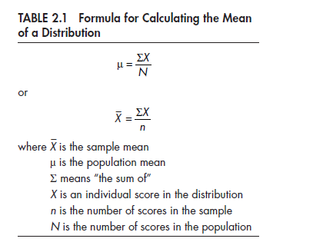

**Econ**

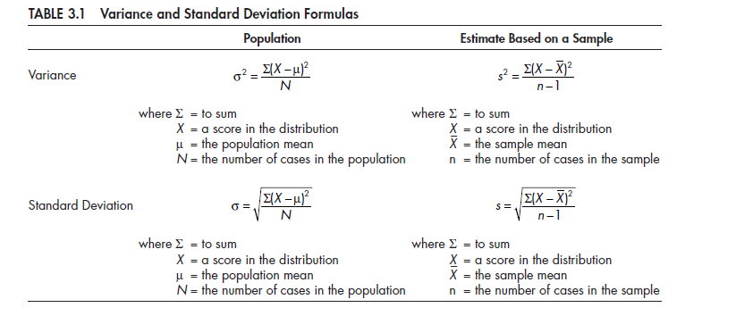

**Perfect Competition**

Perfect competition is a market system characterized by many different buyers and sellers. In the classic theoretical definition of perfect competition, there are an infinite number of buyers and sellers. With so many market players, it is impossible for any one participant to alter the prevailing price in the market. If they attempt to do so, buyers and sellers have infinite alternatives to pursue.

**Monopoly**

A monopoly is the exact opposite form of market system as perfect competition. In a pure monopoly, there is only one producer of a particular good or service, and generally no reasonable substitute. In such a market system, the monopolist is able to charge whatever price they wish due to the absence of competition, but their overall revenue will be limited by the ability or willingness of customers to pay their price.

**Oligopoly**

An oligopoly is similar in many ways to a monopoly. The primary difference is that rather than having only one producer of a good or service, there are a handful of producers, or at least a handful of producers that make up a dominant majority of the production in the market system. While oligopolists do not have the same pricing power as monopolists, it is possible, without diligent government regulation, that oligopolists will collude with one another to set prices in the same way a monopolist would.

**Monopolistic Competition**

Monopolistic competition is a type of market system combining elements of a monopoly and perfect competition. Like a perfectly competitive market system, there are numerous competitors in the market. The difference is that each competitor is sufficiently differentiated from the others that some can charge greater prices than a perfectly competitive firm. An example of monopolistic competition is the market for music. While there are many artists, each artist is different and is not perfectly substitutible with another artist.

**Monopsony**

Market systems are not only differentiated according to the number of suppliers in the market. They may also be differentiated according to the number of buyers. Whereas a perfectly competitive market theoretically has an infinite number of buyers and sellers, a monopsony has only one buyer for a particular good or service, giving that buyer significant power in determining the price of the products produced.

**Class 3**

**Overview**

Recap what we have done

Show Sharks tank

List Ideas

* Feasibility analysis on them

Select Teams

Feasibility Analysis (include lecture on product and selling from 213)

* Week 3 Products and Services Description (WEEK 2)

Websites

**Teaching**

* Recap
  + Small Business
  + Entrepreneurs
  + Ideation
* Excel
* Product and Customer
* Stats Example
* Economics
  + Supply and Demand
* Scaling and business type
  + Tech verse hair salon
* Online
  + Websites and Hosting
* http://www.oregon.gov/business/Pages/toolkit.aspx

cd ~/public_html  
find ./ -type d -exec chmod 755 {} \;  
find ./ -type f -exec chmod 644 {} \;

There are one or more students in this class who require a note taker. The Center for Accessibility Resources (CFAR) is recruiting for a volunteer to do so. Volunteer Note Takers are compensated with a $50 gift card to either the LBCC Campus Store or Food Services at the end of the term for successfully providing notes to students in need. Directions are available for how to sign up and how to upload the notes electronically. Students depend on volunteer note takers for access to class notes. CFAR is asking for a reliable and responsible volunteer to provide this service for the whole term. Note taking is an experience that you can put on your resume or future job applications. If you would like to volunteer please contact me via email or talk to me in class.

**Class 5**

Show both videos

* Do they contradict each other

Show my analysis

**Class 2**

**Topic:**

**Assigned Reading:**

**Course Time Schedule:**

* Gathering Together Farm
* Elevator Pitches
  + Video
* Go over ICA
* Do ICA
* Lecture

<http://block15.com/local-and-sustainable#sustainability-practices>

https://www.gatheringtogetherfarm.com/about-gtf